Department of Computer Science and Engineering

Jahangirnagar University

Savar, Dhaka



# Laboratory Report

CSE-402: Computer Networks Laboratory

**Submitted by**

Md. Ashick Areafin

Exam roll: 160054

Class roll: 2130

Session: 2015-16

4th year 1st Semester

**Submitted to**

Dr. Imdadul Islam

Professor

Department of Computer Science and Engineering

Jahangirnagar University

**Experiment No: 06**

**Experiment Name: IP Telephony .**

**Objectives:**

The purpose of this experiment is to describe how IP-telephony works and discuss what are the advantages and disadvantages compared to the common telephone system widely used nowadays. I also aim to point how IP-telephony is being used and how it can be improved in certain aspects.

**Introduction:**

IP telephony provides a way for you to extend highly secure, reliable, and consistent communications services to all your employees whether they are in the main campus locations, at branch offices, working remotely, or are mobile. IP telephony transmits voice communications over the network using open-standards-based Internet Protocol.Cisco IP telephony solutions are an integral part of Cisco Unified Communications, which unify voice, video, data, and mobile applications on fixed and mobile networks enabling users to easily communicate in any workspace using any media, device, or operating system. Using the network as the platform, Cisco IP telephony solutions help organizations of all sizes realize greater security, resilience, and scalability in addition to the inherent benefits of using a converged network for transport and interconnection.It Provides highly secure, reliable, scalable communications that take advantage of your LAN and WAN.It Improves employee agility and productivity through integration with innovative Cisco Unified Communications and third-party applications.

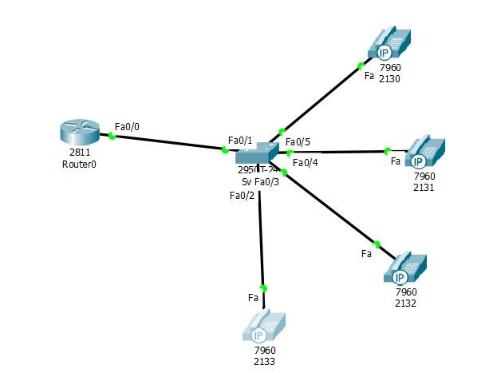

**Figure 1 :** One Router,One Switch and Four IP Phone​

**Router Configuration through CLC :**

Would you like to enter the initial configuration dialog? [yes/no]: no

Router>en

Router#conf t

Enter configuration commands, one per line. End with CNTL/Z.

Router(config)#int fa0/0

Router(config-if)#ip add 192.168.10.63 255.255.255.0

Router(config-if)#no shut

Router(config-if)#exit

Router(config)#ip dhcp pool VOICE

Router(dhcp-config)#network 192.168.10.0 255.255.255.0

Router(dhcp-config)#default-router 192.168.10.63

Router(dhcp-config)#option 150 ip 192.168.10.63

Router(dhcp-config)#exit

Router(config)#telephony-service

Router(config-telephony)#max-dn 4

Router(config-telephony)#max-ephone 10

Router(config-telephony)#ip source-address 192.168.10.63 port 2000

Router(config-telephony)#auto assign 1 to 5

Router(config-telephony)#exit

Router(config)#ephone-dn 1

Router(config-ephone-dn)#%LINK-3-UPDOWN: Interface ephone_dsp DN 1.1, changed state to up

Router(config-ephone-dn)#number 2130

Router(config-ephone-dn)#exit

Router(config)#ephone-dn 2

Router(config-ephone-dn)#%LINK-3-UPDOWN: Interface ephone_dsp DN 2.1, changed state to up

%IPPHONE-6-REGISTER: ephone-2 IP:192.168.10.1 Socket:2 DeviceType:Phone has registered.

Router(config-ephone-dn)#%DHCPD-4-PING_CONFLICT: DHCP address conflict: server pinged 192.168.10.4.

%DHCPD-4-PING_CONFLICT: DHCP address conflict: server pinged 192.168.10.3.

Router(config-ephone-dn)#number 2131

Router(config-ephone-dn)#exit

Router(config)#ephone-dn 3

Router(config-ephone-dn)#%LINK-3-UPDOWN: Interface ephone_dsp DN 3.1, changed state to up

Router(config-ephone-dn)#number 2132

Router(config-ephone-dn)#ephone-dn 3

%IPPHONE-6-REGISTER: ephone-4 IP:192.168.10.4 Socket:2 DeviceType:Phone has rexit

Router(config)#exit

%IPPHONE-6-REGISTER: ephone-1 IP:192.168.10.3 Socket:2 DeviceType:Phone has registered.

Router(config)#ephone-dn 4

Router(config-ephone-dn)#%LINK-3-UPDOWN: Interface ephone_dsp DN 4.1, changed state to up

Router(config-ephone-dn)#number 2133

Router(config-ephone-dn)#

%IPPHONE-6-REGISTER: ephone-3 IP:192.168.10.2 Socket:2 DeviceType:Phone has registered.

Router(config-ephone-dn)#exit

**Switch Configuration through CLC :**

Switch>en

Switch#conf t

Enter configuration commands, one per line. End with CNTL/Z.

Switch(config)#int range fa0/1-10

Switch(config-if-range)#switchport mode access

Switch(config-if-range)#switchport voice vlan 1

Switch(config-if-range)#

**Verify the circuit with dialing:**

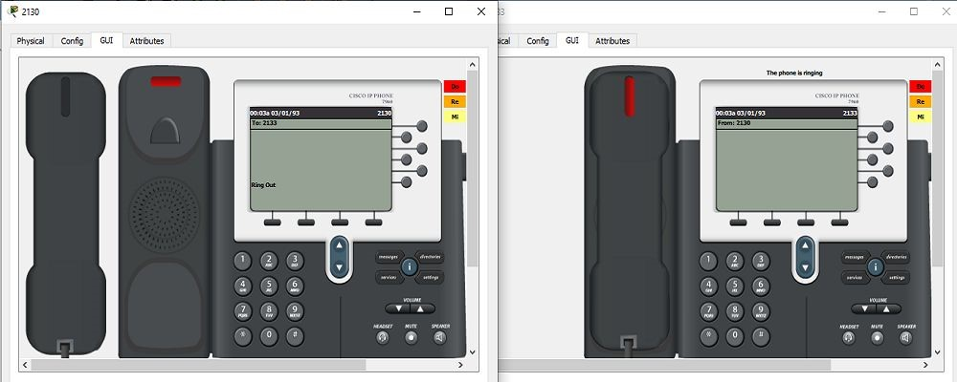

**Figure 2 :** The Phone is ringing​

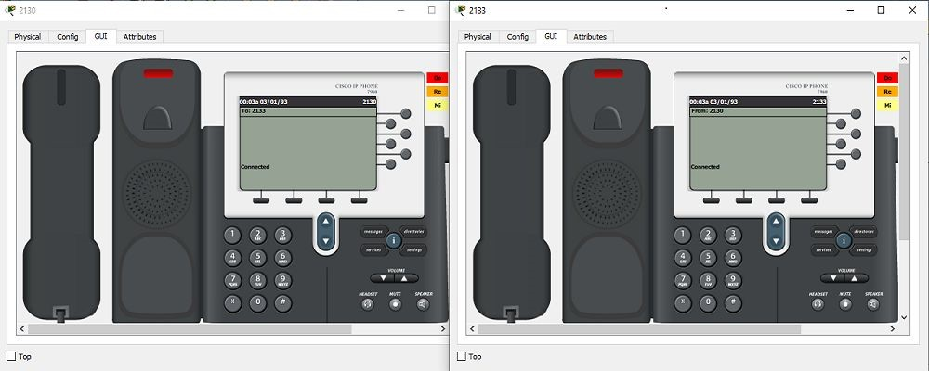

**Figure 3 :** The Phone is connected​

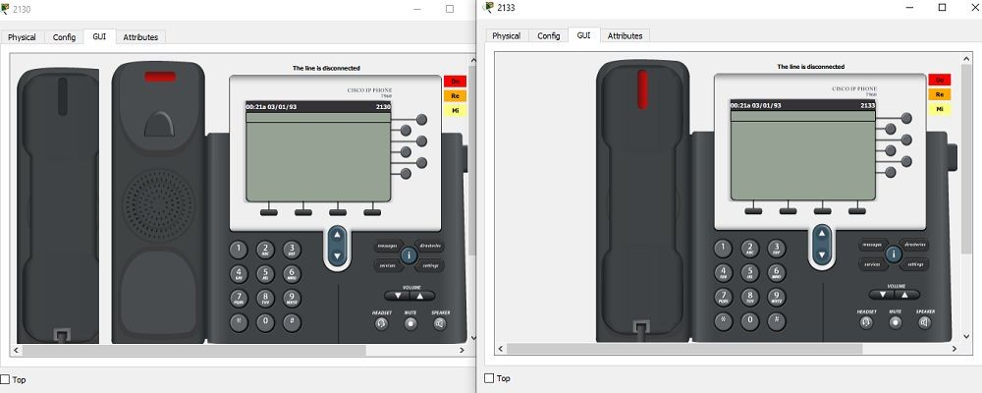

**Figure 4 :** The Phone is disconnected​

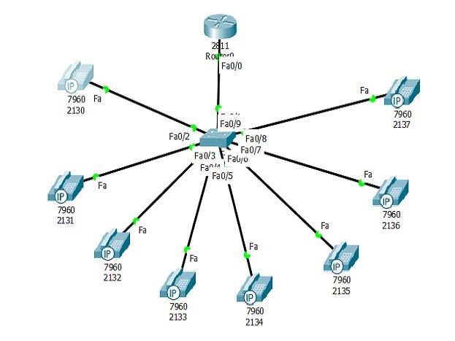

**Figure 5 :** One Router,One Switch and Eight IP Phone​

**Router Configuration through CLC :**

--- System Configuration Dialog ---

Would you like to enter the initial configuration dialog? [yes/no]: no

Press RETURN to get started!

Router>en

Router#conf t

Enter configuration commands, one per line. End with CNTL/Z.

Router(config)#int fa0/0

Router(config-if)#ip add 192.168.10.63 255.255.255.0

Router(config-if)#no shut

Router(config-if)#

%LINK-5-CHANGED: Interface FastEthernet0/0, changed state to up

%LINEPROTO-5-UPDOWN: Line protocol on Interface FastEthernet0/0, changed state to up

Router(config-if)#exit

Router(config)#ip dhcp pool VOICE

Router(dhcp-config)#network 192.168.10.0 255.255.255.0

Router(dhcp-config)#default-router 192.168.10.63

Router(dhcp-config)#option 150 ip 192.168.10.63

Router(dhcp-config)#exit

Router(config)#telephony-service

Router(config-telephony)#max-dn 8

Router(config-telephony)#max-ephone 12

Router(config-telephony)#ip source-address 192.168.10.63 port 2000

Router(config-telephony)#auto assign 1 to 9

Router(config-telephony)#exit

Router(config)#ephone-dn 1

Router(config-ephone-dn)#%LINK-3-UPDOWN: Interface ephone_dsp DN 1.1, changed state to up

Router(config-ephone-dn)#number 2130

Router(config-ephone-dn)#exit

Router(config)#

%IPPHONE-6-REGISTER: ephone-3 IP:192.168.10.2 Socket:2 DeviceType:Phone has registered.

Router(config)#ephone-dn 2

Router(config-ephone-dn)#%LINK-3-UPDOWN: Interface ephone_dsp DN 2.1, changed state to up

Router(config-ephone-dn)#number 2131

Router(config-ephone-dn)#exit

Router(config)#

%IPPHONE-6-REGISTER: ephone-1 IP:192.168.10.11 Socket:2 DeviceType:Phone has registered.

Router(config)#ephone-dn 3

Router(config-ephone-dn)#%LINK-3-UPDOWN: Interface ephone_dsp DN 3.1, changed state to up

Router(config-ephone-dn)#number 2132

Router(config-ephone-dn)#

%IPPHONE-6-REGISTER: ephone-8 IP:192.168.10.3 Socket:2 DeviceType:Phone has registered.

Router(config-ephone-dn)#exit

Router(config)#ephone-dn 4

Router(config-ephone-dn)#%LINK-3-UPDOWN: Interface ephone_dsp DN 4.1, changed state to up

Router(config-ephone-dn)#number 2134

Router(config-ephone-dn)#exit

Router(config)#

%IPPHONE-6-REGISTER: ephone-4 IP:192.168.10.4 Socket:2 DeviceType:Phone has registered.

Router(config)#ephone-dn 5

Router(config-ephone-dn)#%LINK-3-UPDOWN: Interface ephone_dsp DN 5.1, changed state to up

Router(config-ephone-dn)#number 2135

Router(config-ephone-dn)#exit%DHCPD-4-PING_CONFLICT: DHCP address conflict: server pinged 192.168.10.5.

Router(config)#

%IPPHONE-6-REGISTER: ephone-7 IP:192.168.10.6 Socket:2 DeviceType:Phone has registered.

Router(config)#ephone-dn 6

Router(config-ephone-dn)#%LINK-3-UPDOWN: Interface ephone_dsp DN 6.1, changed state to up

Router(config-ephone-dn)#number 2136

Router(config-ephone-dn)#exit

Router(config)#

%IPPHONE-6-REGISTER: ephone-6 IP:192.168.10.1 Socket:2 DeviceType:Phone has registered.

Router(config)#ephone-dn 7

Router(config-ephone-dn)#%LINK-3-UPDOWN: Interface ephone_dsp DN 7.1, changed state to up

Router(config-ephone-dn)#number 2137

Router(config-ephone-dn)#exit

Router(config)#

%IPPHONE-6-REGISTER: ephone-2 IP:192.168.10.5 Socket:2 DeviceType:Phone has registered.

Router(config)#ephone-dn 8

Router(config-ephone-dn)#%LINK-3-UPDOWN: Interface ephone_dsp DN 8.1, changed state to up

Router(config-ephone-dn)#number 2138

Router(config-ephone-dn)#exit

Router(config)#

%IPPHONE-6-REGISTER: ephone-5 IP:192.168.10.12 Socket:2 DeviceType:Phone has registered.

**Switch Configuration through CLC :**

Switch>en

Switch#conf t

Enter configuration commands, one per line. End with CNTL/Z.

Switch(config)#int range fa0/1-12

Switch(config-if-range)#switchport mode access

Switch(config-if-range)#switchport voice vlan 1

Switch(config-if-range)#

**Verify the circuit with dialing:**

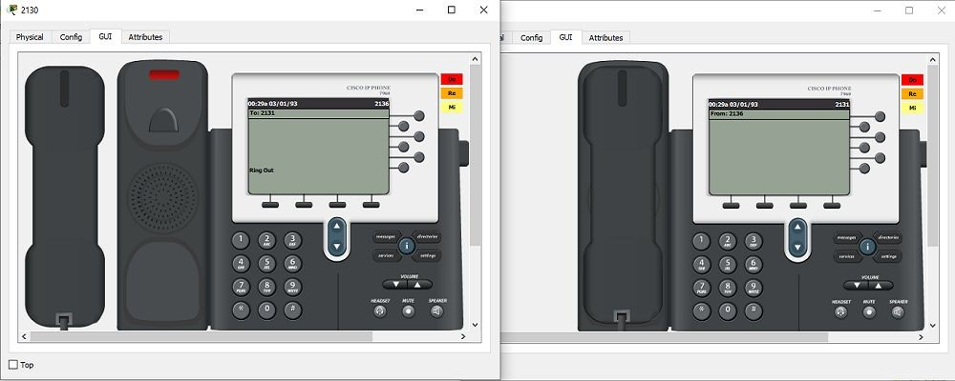

**Figure 6 :** The Phone is ringing​

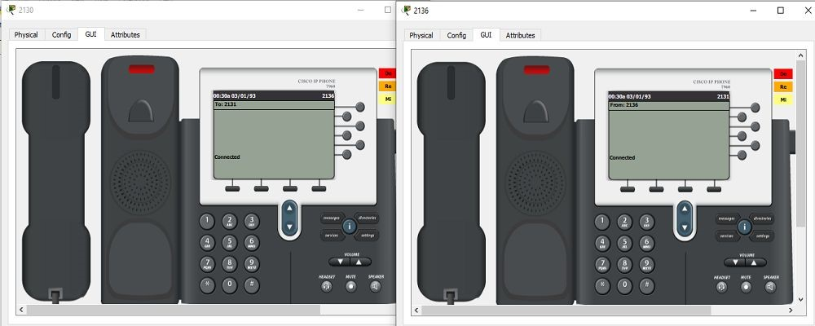

**Figure 7 :** The Phone is Connected​

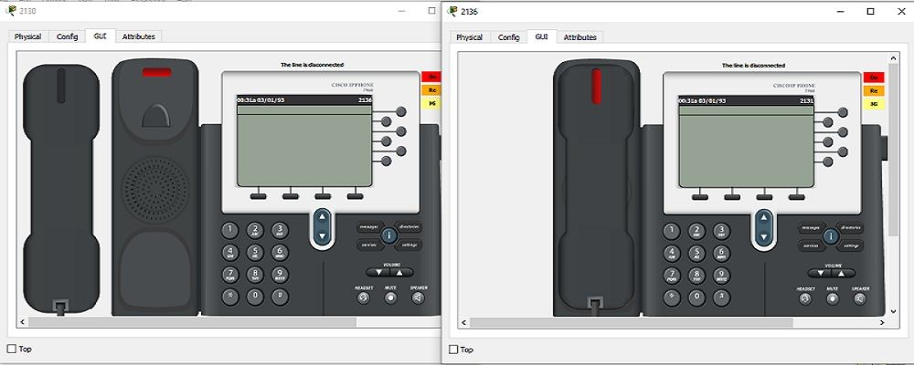

**Figure 8 :** The Phone is Disconnected​